A MICRO PROJECT REPORT
ON

"SmartStudy AI – Intelligent Study Planner"

Subject: Foundation of Artificial Intelligence
(Course Code: 2ADPC204)

Submitted in partial fulfilment of the requirement for The award of the Degree in B.TECH

SUBMITTED BY
1. Name of Student :- Sayeeda Sameer Tamboli Roll No.:- 2022

UNDER THE GUIDANCE OF
Prof. Ms.Priyanka Suryawanshi.

Annasaheb Dange College of Engineering and Technology,Ashta
Department of AI & DS. Academic Year: 2026 – 2027.


CERTIFICATE

This is to certify that Ms. Sayeeda Sameer Tamboli of III Semester of Degree in B. Tech of Institute ADCET has successfully completed the Micro Project work entitled " SmartStudy AI – Intelligent Study Planner " in the subject “ Foundation Of AI& DS”(Course Code: 2ADPC204) for the academic year 2026 to 2027 as prescribed in the curriculum.

Place: Ashta
Date:

Subject Teacher
(Signature)

ACKNOWLEDGEMENT

I would like to express my sincere gratitude to my guide Prof. Ms.Priyanka Suryawanshi for the valuable guidance and constant support throughout this micro project on “AI Career Recommendation System” I am also thankful to Mrs. Asma Shaikh, Head of the Department, and to our Director Dr. L. Y. Waghmode. for providing the computer laboratory and software facilities required to complete this work. Finally, I thank all the teaching and non-teaching staff, my family and my friends who helped me directly or indirectly in completing this project.

Sayeeda S Tamboli
Roll No:- 2022

INDEX

Sr. No. | Title | Page No.
1 | Aims / Benefits of the Micro Project
2 | Course Outcomes Achieved
3 | Literature Review
4 | Actual Methodology Followed
5 | Actual Resources Used
6 | Outputs of the Micro Project
7 | Skills Developed
8 | Applications of the Micro Project
9 | Conclusion
10 | References

MICRO PROJECT REPORT

SmartStudy AI – Intelligent Study Planner

Aims / Benefits of the Micro Project

Aim
To design and develop a website named SmartStudy AI – Intelligent Study Planner that helps students organise their studies, prioritise subjects, create study schedules, and monitor their learning progress using basic artificial intelligence concepts.

Objectives
- To understand the basic concepts and applications of Artificial Intelligence.
- To develop a user-friendly website for student study planning.
- To implement rule-based reasoning for prioritising study tasks.
- To generate a study timetable based on subject difficulty, deadlines, and available study time.
- To help students manage their time efficiently and complete tasks on schedule.
- To display study progress through a dashboard.
- To understand how intelligent decision-making can solve real-life problems.

Benefits
- Helps students organise their daily study activities.
- Reduces confusion when preparing for multiple subjects.
- Identifies important tasks based on deadlines and difficulty.
- Provides a structured and personalised study schedule.
- Encourages regular study habits and progress tracking.
- Demonstrates the practical application of AI in education.

Course Outcomes Achieved
1.Understood the basic concepts of Artificial Intelligence.
2. Learned how technology can be used to solve real-world problems.
3. Understood the importance of career recommendation systems.
4. Learned the basic process of designing and developing a website.
5. Improved logical thinking and problem-solving skills.
6. Understood how user requirements can be used to provide relevant career guidance.
7. Gained practical knowledge of web-based applications.

Literature Review

Artificial Intelligence is a branch of computer science that focuses on developing systems capable of performing tasks that normally require human intelligence. These tasks include reasoning, learning, problem-solving, planning, and decision-making.
AI has several applications in education, including intelligent tutoring systems, adaptive learning platforms, automated assessment, and personalised learning recommendations.
Traditional study planning is usually performed manually using notebooks, calendars, or general-purpose scheduling applications. Although these methods help students organise tasks, they may not automatically prioritise subjects based on difficulty, deadlines, and available study time.
An intelligent study planner can address this limitation by using rules and decision-making techniques to recommend study priorities. For example, a subject with a near examination date and a high difficulty level can be assigned a higher priority than a relatively easy subject whose examination is scheduled later.
The proposed SmartStudy AI website uses basic rule-based reasoning to generate useful study recommendations. It combines simple AI concepts with web development to provide an accessible and practical solution for students.

Actual Methodology Followed

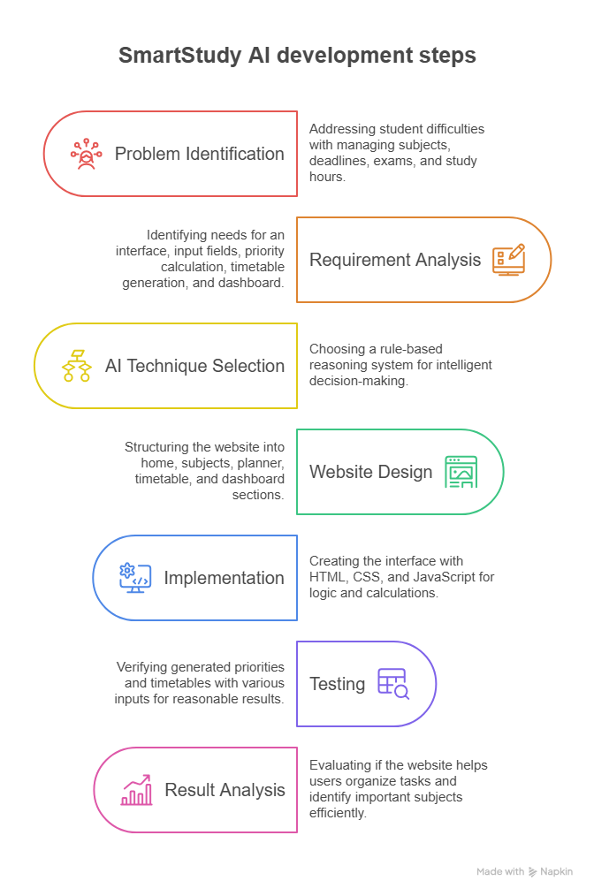

Actual Resources Used

Hardware:
  - Computer or laptop
  - Keyboard and monitor

Software:
  - Operating System: Windows
  - Programming Language: Python
  - Code Editor: Visual Studio Code (VS Code)

Other Resources:
  - Python and Tkinter documentation
  - Course notes on Artificial Intelligence
  - Career-related information
  - Internet resources for reference and learning

Outputs of the Micro Project:

Skills Developed
The development of this micro-project helps develop the following skills:
- AI Fundamentals: Understanding rule-based systems and intelligent decision-making.
- Logical Thinking: Designing rules to prioritise study tasks.
- Web Development: Understanding the structure and design of websites.
- Programming Skills: Using JavaScript to process user inputs and generate outputs.
- Problem-Solving: Converting a real-life student problem into a technical solution.
- Testing and Debugging: Identifying and correcting errors in the website.
- UI/UX Design: Creating an attractive and user-friendly interface.
- Project Management: Planning, implementing, and documenting a micro-project.

Applications of the Micro Project
SmartStudy AI can be applied in the following areas:
- College Students: Organising subject-wise study schedules.
- Examination Preparation: Prioritising subjects according to examination dates and difficulty.
- Assignment Management: Scheduling assignments according to deadlines.
- Revision Planning: Allocating time for revision of previously studied topics.
- Time Management: Helping students distribute available study hours across subjects.
- Self-Learning: Supporting students who follow independent learning schedules.
- Academic Support: Serving as a basic planning tool for tutors and educators.

Conclusion :-

- The AI Career Recommendation System was successfully designed as a basic desktop application using Python and Tkinter. It provides a user-friendly interface for selecting interests and technical skills and displays matching career options with required skills and learning roadmaps.
- The project demonstrates the practical application of Python programming, graphical user interface development, data organization, and rule-based recommendation logic. It also helped improve logical thinking, problem-solving, testing, and debugging skills.
- The current system provides basic career suggestions and does not replace professional career counselling. In the future, it can be improved by adding more career options, detailed learning resources, user profiles, and a trained machine learning model for more personalized recommendations.

Reference :-
- Python Official Documentation — https://docs.python.org/3/
- Python Tkinter Documentation — https://docs.python.org/3/library/tkinter.html
- Foundation of Artificial Intelligence course notes.
- Reference materials related to Python programming and career guidance.

